|  |  |  |
| --- | --- | --- |
| Product Catalogue | SD card connector |  |
| Card connection method | Self-folding type |  |
| Card type | MicroSD card (TF card) |  |
| Connector type | Card slot |  |
| Maximum height of the body | - |  |
| Contact material | - |  |
| Contact coating | - |  |
| Operating temperature range | - |  |
| Welding temperature (maximum value) | - |  |

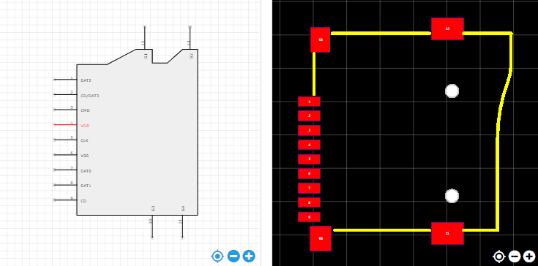

<https://item.szlcsc.com/112422.html>